**EEE VT**

**By: Amogh Garg(2020UCO1688)**

**QUESTION 1:**

Circuit: 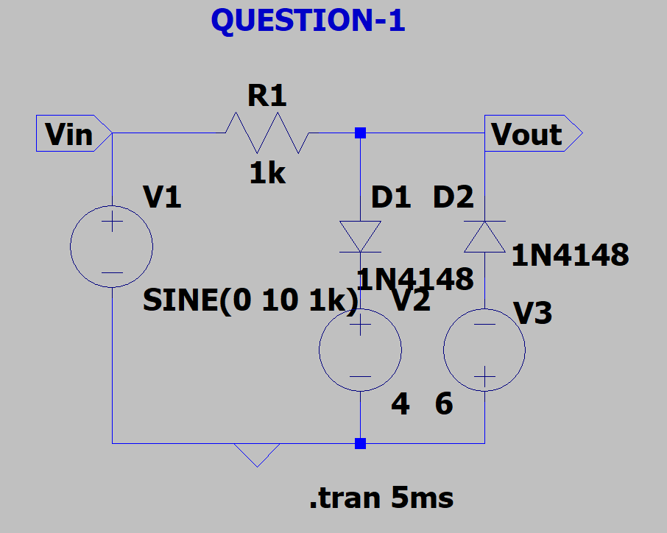

Output: 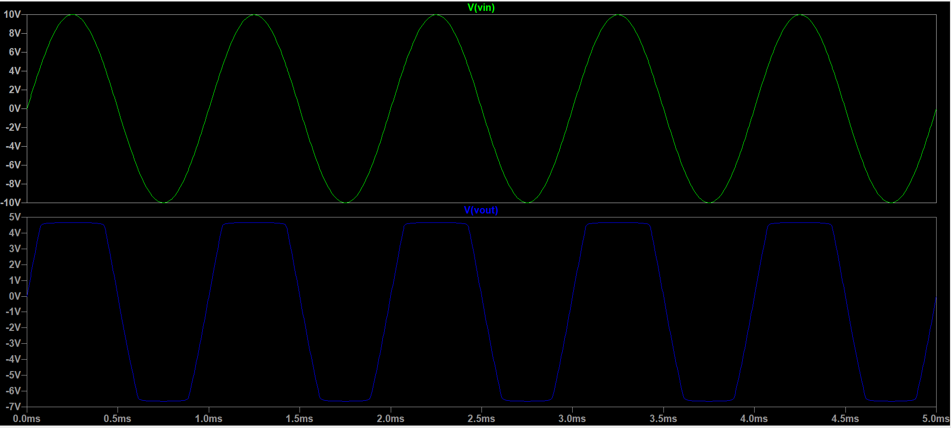

**QUESTION-2:**

Circuit: 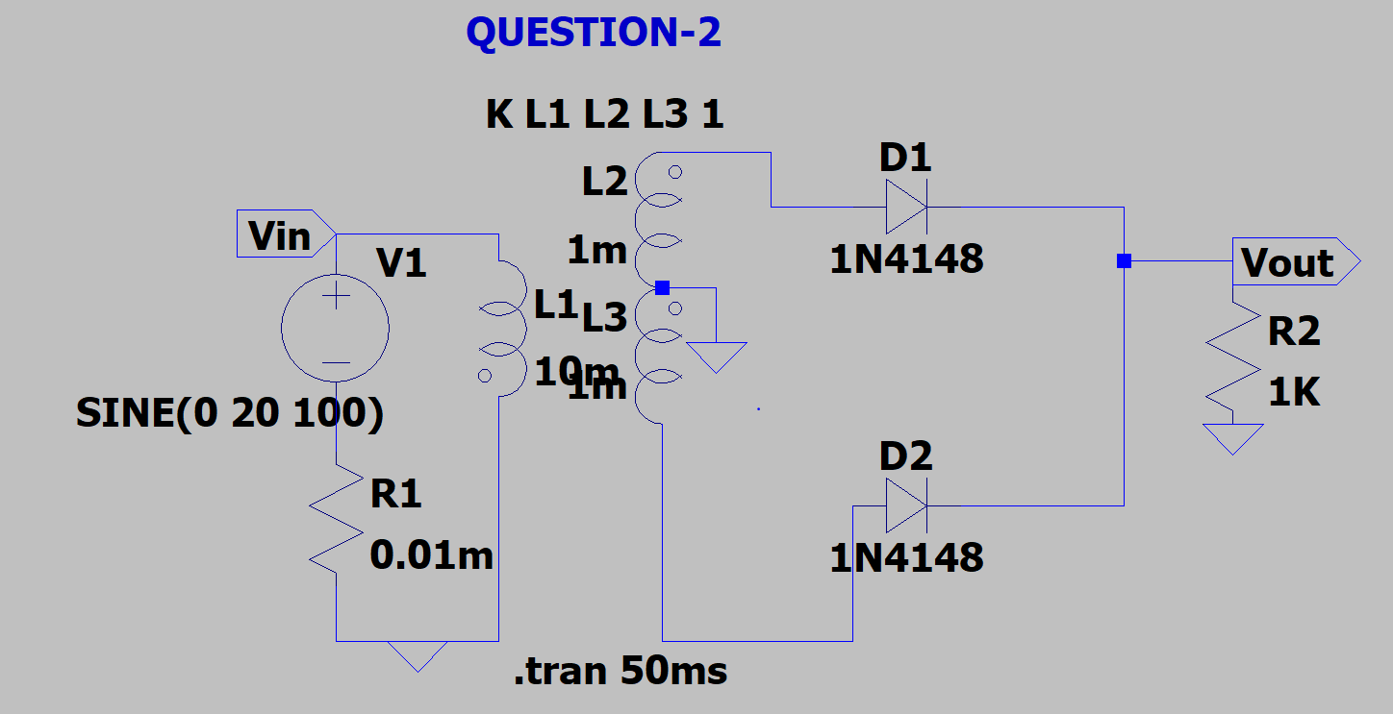

Output: 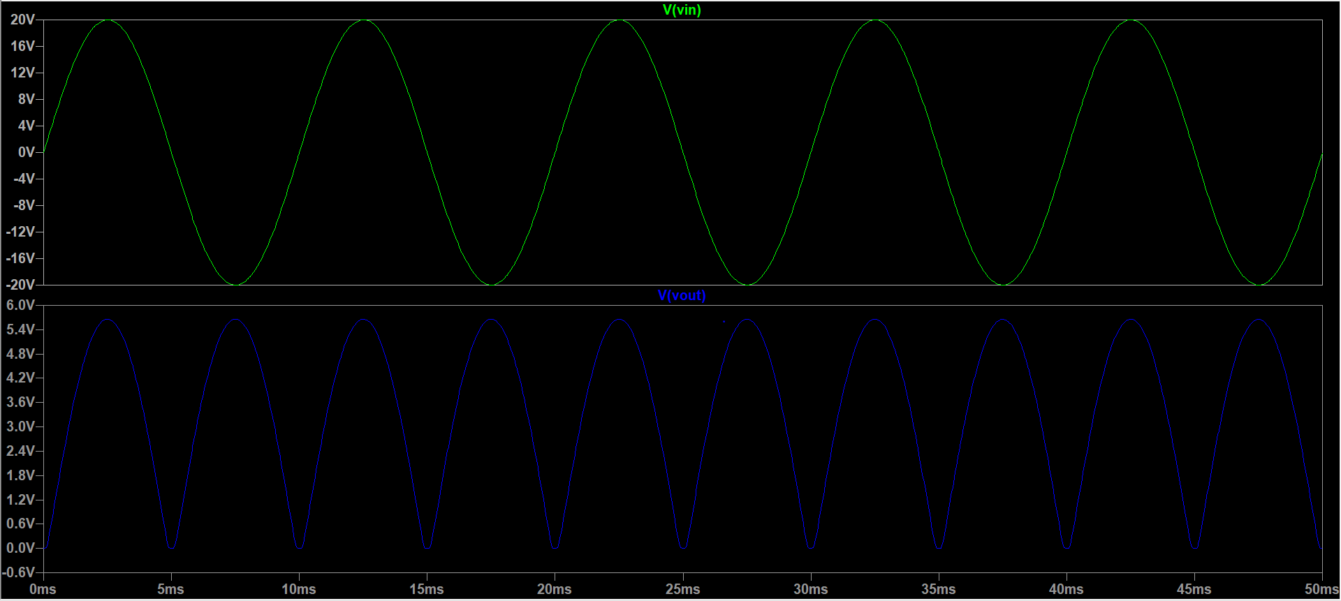

**By: Amogh Garg**

**2020UCO1688**

**COE (SECTION-3)**